Chapter 6 Smith Exercises & Labs

Exercise 6-1.

1. a. double gradeAverages[6];

b. string lastNames[7];

c. int ages[10];

1. a. int wholeNumbers[] = {2, 4, 6, 8, 10};

b. string lastNames[] = {“Carlson”, “Matthews”, “Cooper”};

c. double prices[] = {15.00, 122.00, 7.50};

1. int customerNumber[];

customerNumber[0] = 32;

1. numbers[1] is at memory location 4004

numbers[4] is at memory location 4016

Lab 6-1.

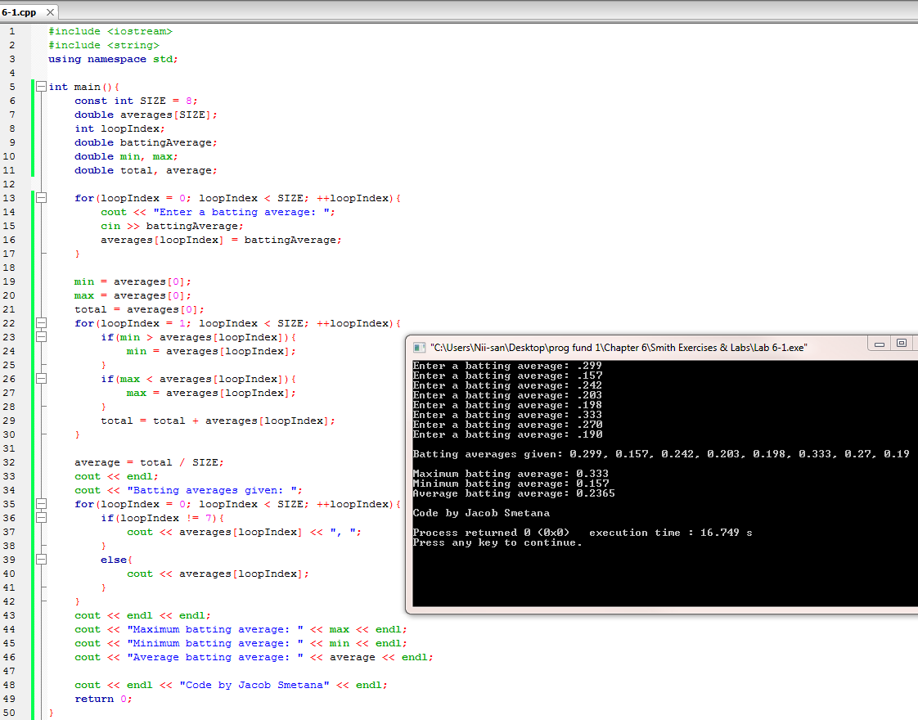

Exercise 6-2.

1. Is the for loop written correctly?

No. Replace **<=** with just **<**.

1. Which variable is the flag?

The variable **foundIt**.

1. Is the flag variable declared correctly?

It works but should be declared as a boolean instead.

1. Is the comparison in the if statement done correctly?

Yes.

Lab 6-2.

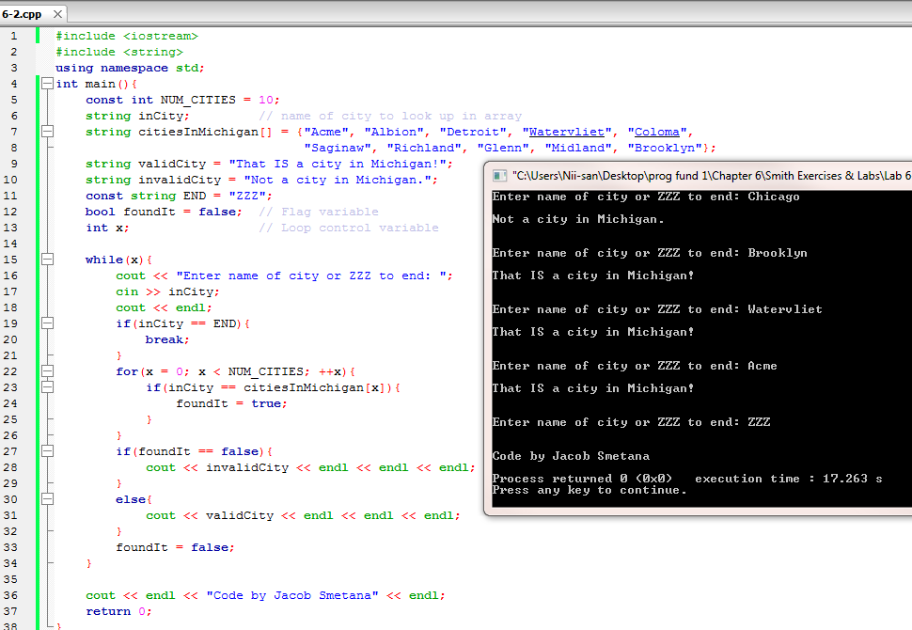

Exercise 6-3.

1. Are the arrays declared and initialized correctly?

No. They need curly braces.

1. Is the for loop written correctly?

No. **i = MAX_CITIES** should be **i < MAX_CITIES**

1. As written, how many times will the for loop execute?

Never, because **i** will never equal **MAX_CITIES**

1. How would you describe the purpose of the statement **foundIt = i;**?

Its purpose is to be compared to the appropriate elements in both arrays.

Lab 6-3.

